<https://github.com/udacity/deep-learning-v2-pytorch>

Applications

* Games
* Diagnosis
* Self-driving cars
* 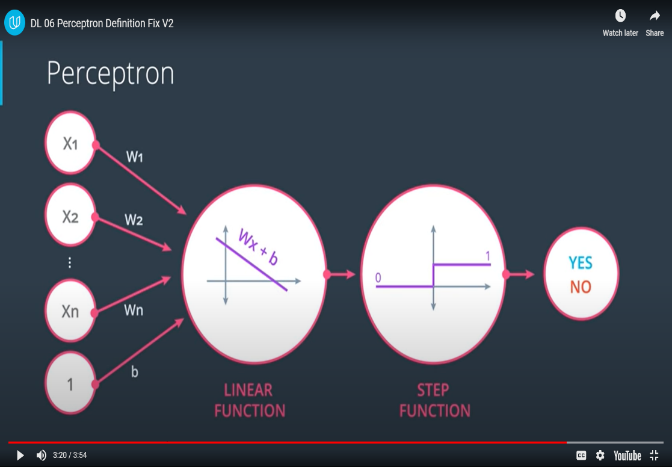Stock prices

NN tries to draw a best separation boundaries between data classes.

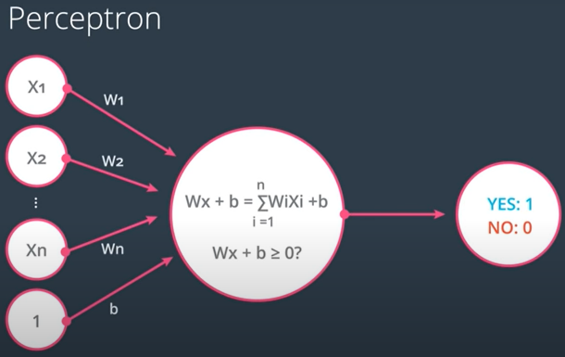

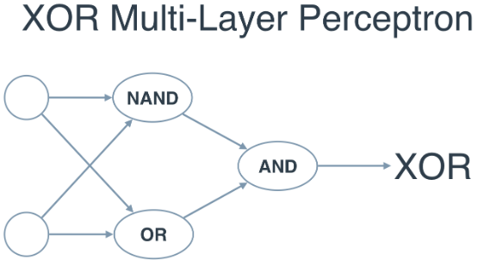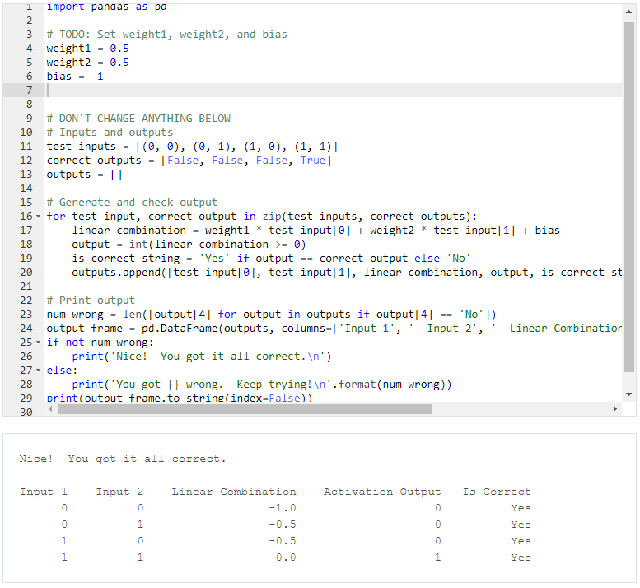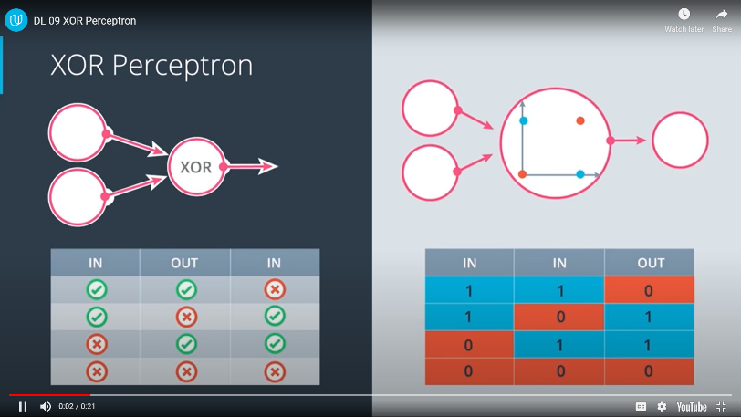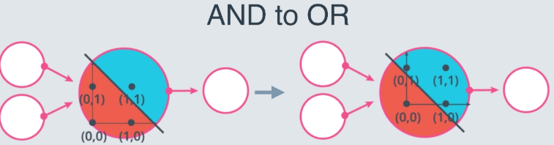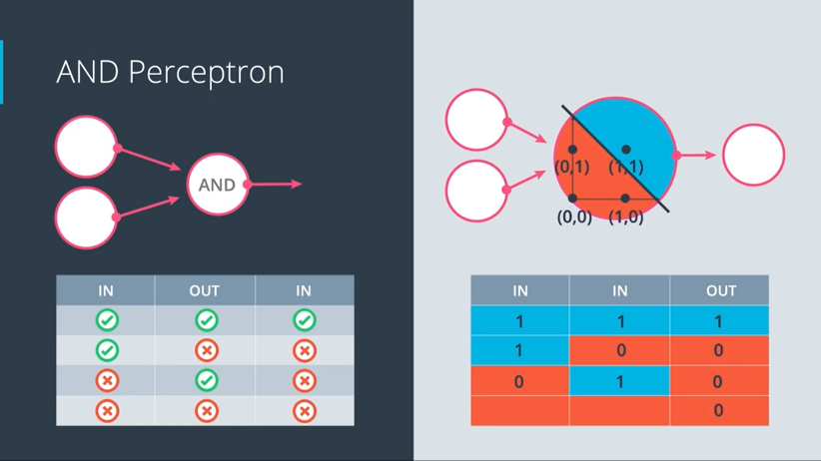AND to OR 🡪 Increase weights & decrease bias!!!

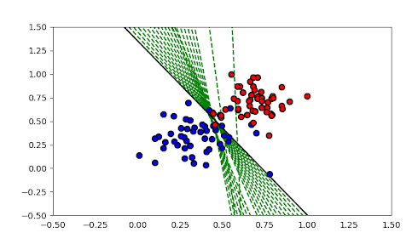**Error/ activation function**

* Distance (magnitude of value) by which present result differs from target result
* Error function penalizes misclassified points more and correctly classified points less.
* Minimizing total error is target

**One hot encoding**

* Each category in categorical column is represented by label 1 and rest are 0

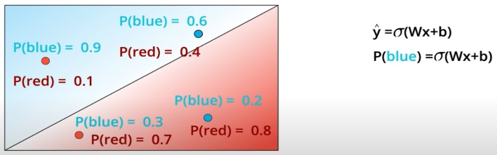

**Maximum likelihood**

* Second model is a better classifier as it improves the likelihood of classification; i.e. classifier prediction is more likely to be actual class of the point
* 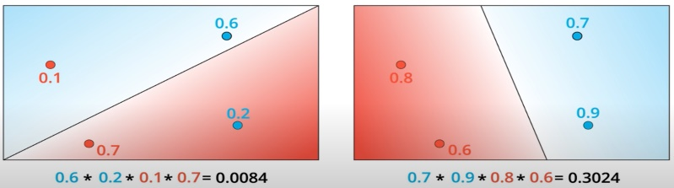Multiplications are tedious!
* Log(ab) = log(a) + log(b)

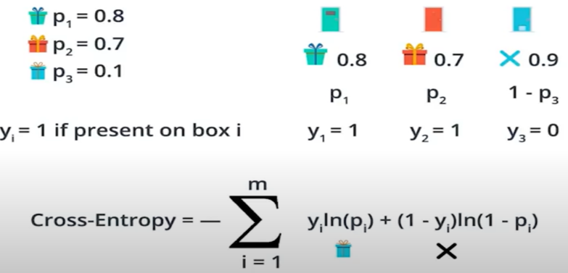

**CROSS ENTROPY**

* -ve of sum of log(a) + log(b) + ….. is called CROSS ENTROPY
* Cross entropy tending to 0 is good
* Cross entropy tending to ∞ is bad

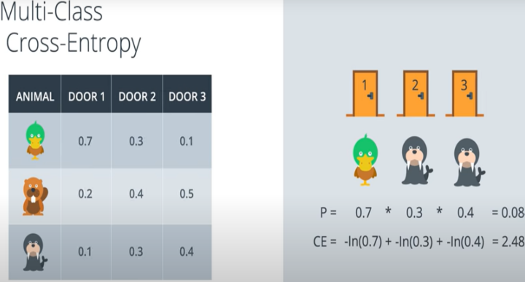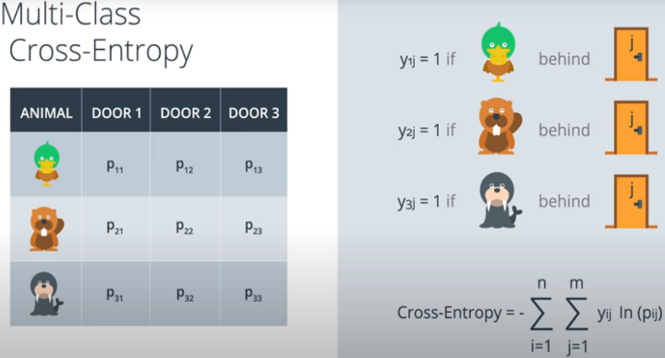

**Error function**

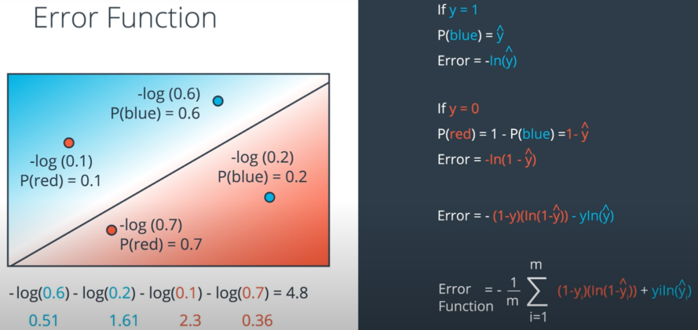

* Sigmoid function $σ\left(x\right)=e^{x}/e^{x}+1$
* $\hat{y}$ Is nothing but activation function $\hat{y} = σ\left(W*X+b\right)$
* Goal is to minimize E(W, b)

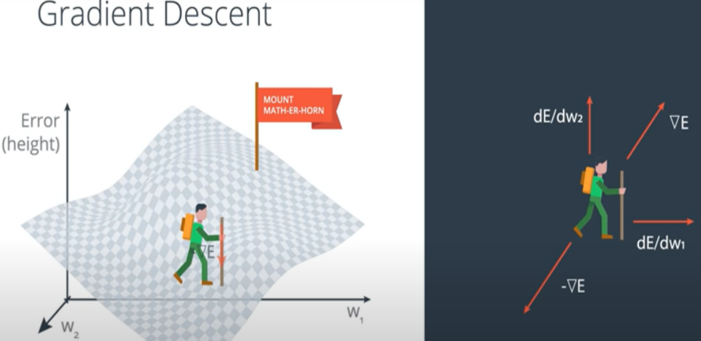**Gradient Descend**

* Vector sum of δ (E) wrt W1 and W2 are calculated
* Vector sum indicates direction which maximizes δ(E)
* Negative of δ(E) is taken to change W to new W’ until global minima is reached

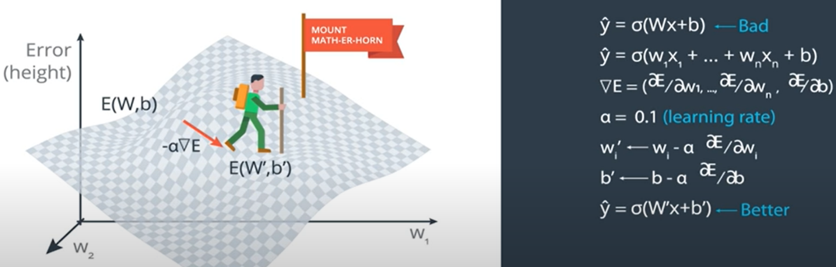

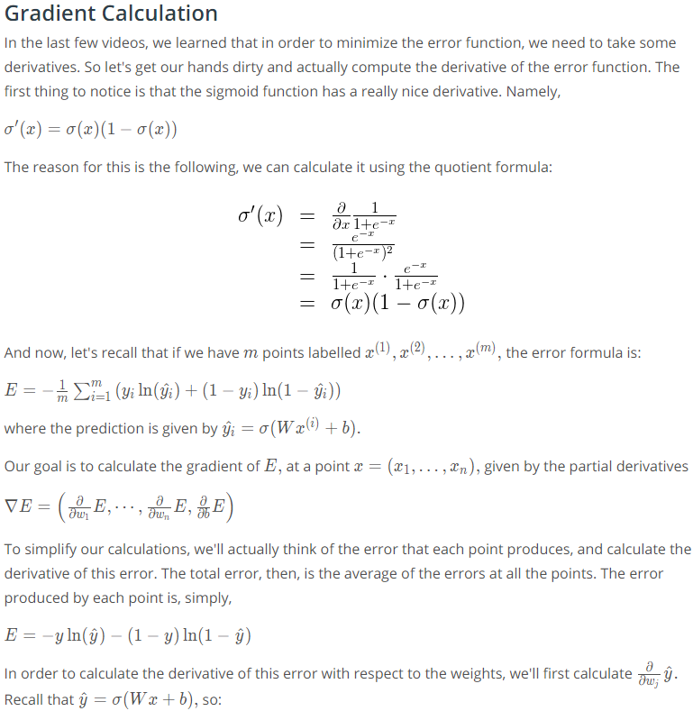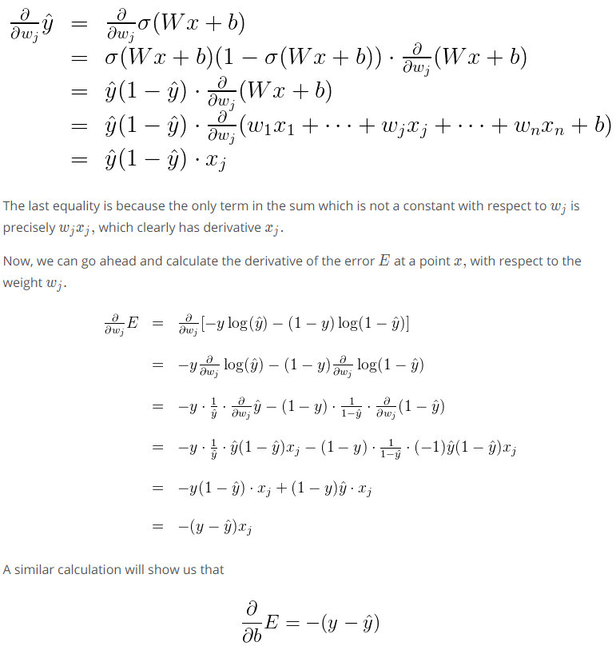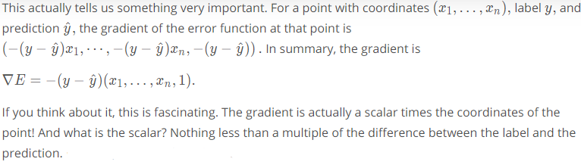

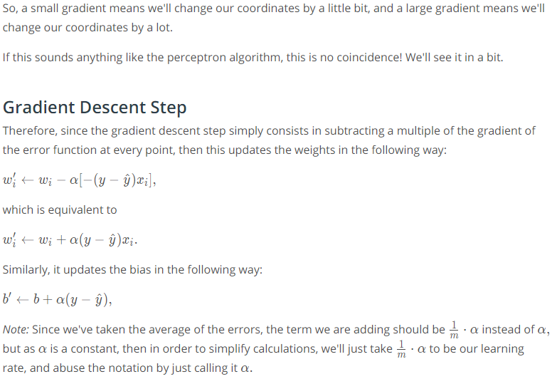

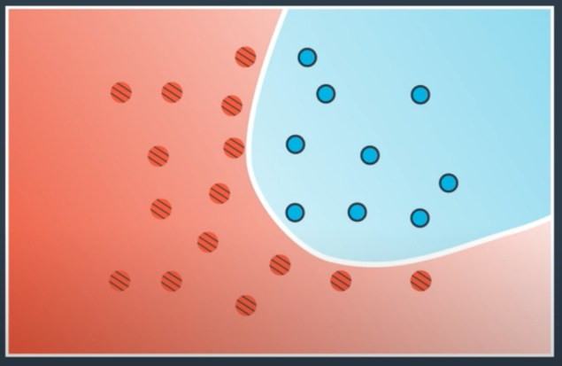**Nonlinear models**

* **Perceptron** treatsdata points to be 1 or 0
* **Gradient descent**  assigns probability to a datapoint being 1 or 0
* **Similarly, nonlinear models assign probability to datapoints being 1 or 0**

**AND**

**Draws a parabola which is a set of datapoints equally likely to be 1 or 0**

**Neural network**

* Two linear models can be combined by adding probabilities and normalizing them using activation function
* 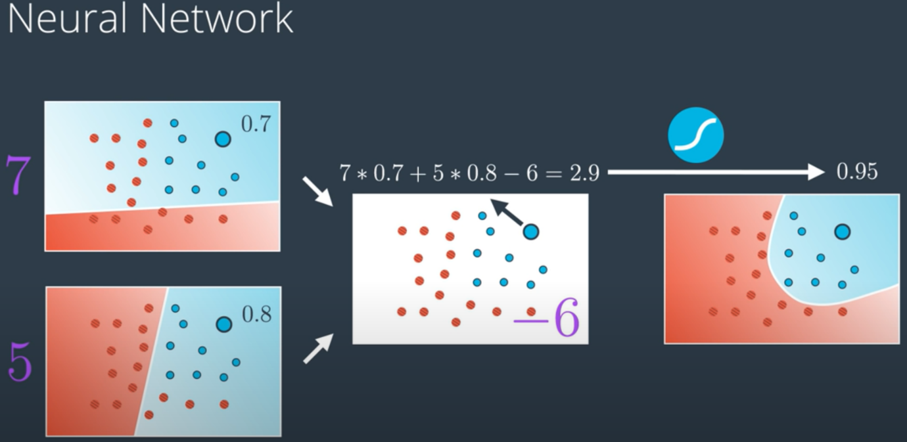Models can be assigned weights to adjust influence on result

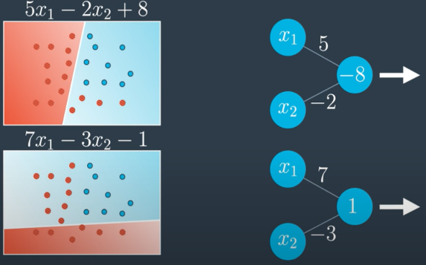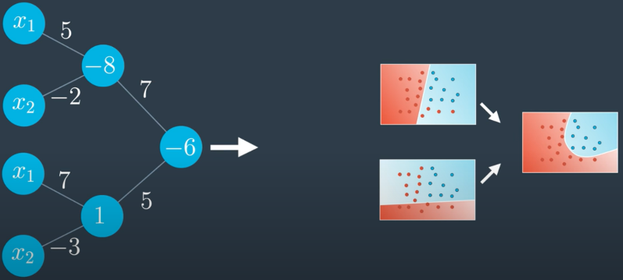**Addition of 2 simple linear models contribute to a Nonlinear model**

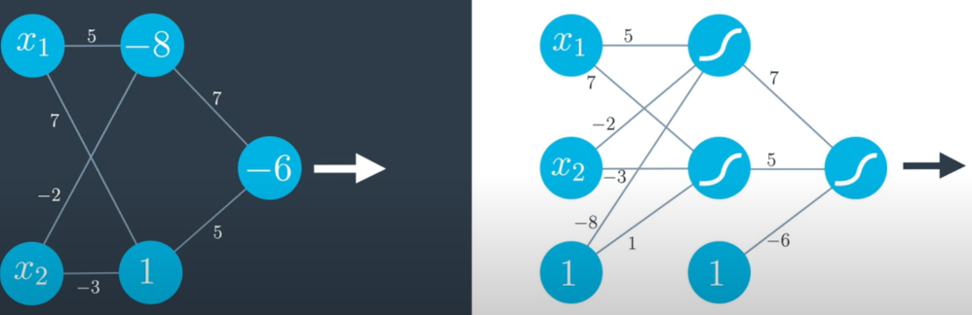**Above representations are equivalent to:**

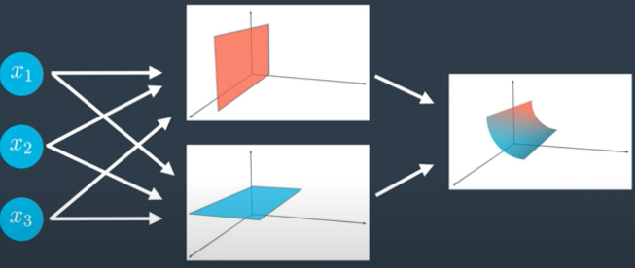**Multidimensional NN**

* As input dimensions are >2, locus of separation is no more line, but a plane

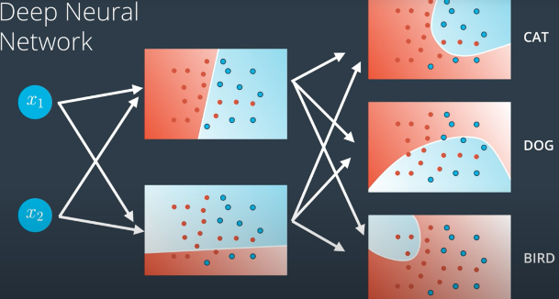**Multiclass NN**

* If output has more than 2 class, output layer has more than 1 nodes

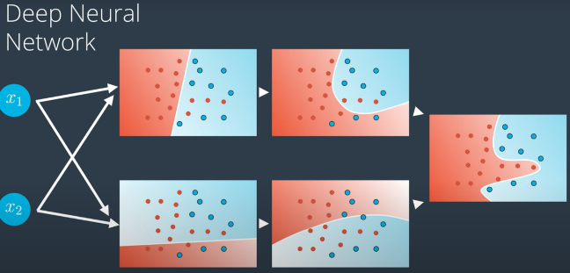**Deep NN**

**Multiple hidden layers generate more complex classification/ regression boundaries**

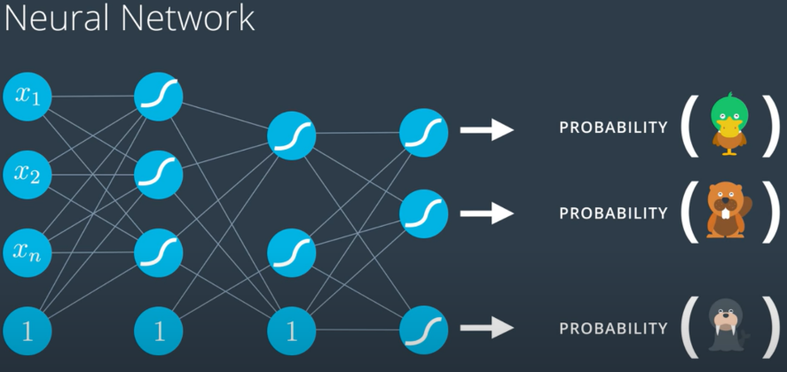**Multiclass classification DNN**

* **Input layer** presents features [wings, bill, claws, weight, length etc]
* **Hidden layers** comprehend meaning
* **Output layer** applies softmax to decide probability of input animal to belong to certain class
* **Softmax**

$$P(y=j∣b\{x\} )=e^{X^{T}W_{j}} / \sum_{k=1}^{K}{e^{X^{T}W_{k}}}$$

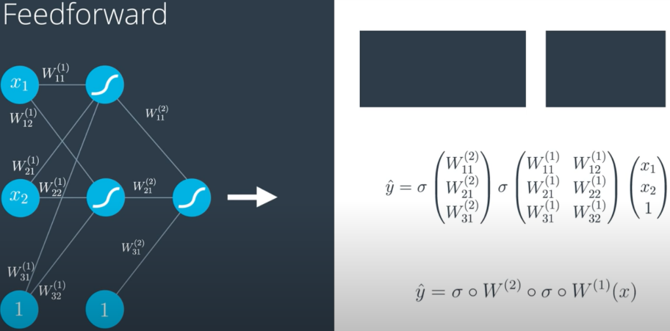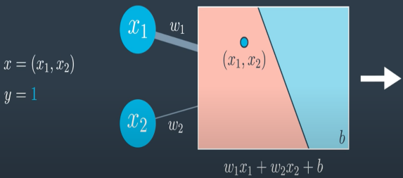**Feedforward NN**

* **Training NN is modifying edge weights so that data is well modeled and maximum data is classified/ regressed correctly**

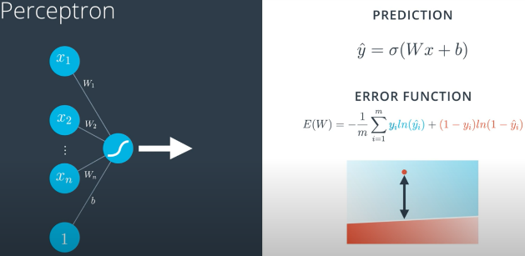**Error Function**

* **Error function quantifies classification**
* If datapoint is correctly classified, it would be nearly 0
* Else, it would be large value with magnitude proportional to distance from plane of separation

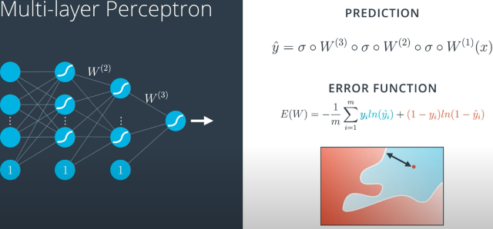For DNN, though y_hat is now more complicated, error function remains the same for binary classification

**BACKPROPOGATION**

* Doing a feedforward operation.
* Comparing the output of the model with the desired output.
* Calculating the error.
* Running the feedforward operation backwards (backpropagation) to spread the error to each of the weights.
* Use this to update the weights, and get a better model.
* Continue this until we have a model that is good.

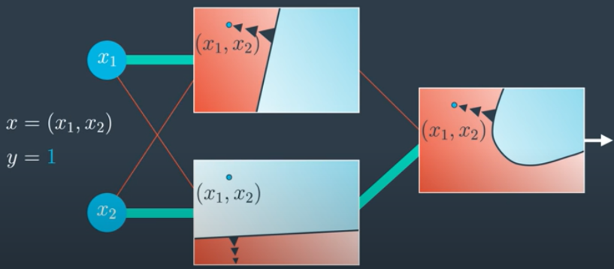Process

* Initially, model is misclassifying
* In order to get classified as Blue, point needs boundary to “Come closer to it”
* **Since, bottom model in hidden layer is correctly classifying, we can endorse its weight to output layer And;** as top model is misclassifying, its weight can be decreased
* **Similarly, as top model misclassifies, its boundary needs to come closer to point and boundary for lower model needs to be pushed further away**

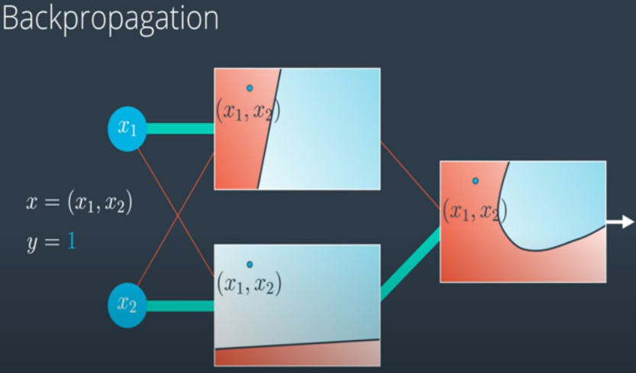

**As seen, TWEAKING WEIGHTS GIVES BETTER BOUNDARY OF SEPRATION; REDUCING ERROR**

**AS SEEN EARLIER:**

$$\frac{∂ σ(x)}{∂ x}= σ(x)*(1-σ(x))$$

**gradient = $∇E = (\frac{∂E}{∂W_{1}},\frac{∂E}{∂W_{2}},...\frac{∂E}{∂W_{n}}, \frac{∂E}{∂W_{b}})$ where $\frac{∂E}{∂W_{j}}=(y -\hat{y})*x_{j}$**

**gradient descent 🡪**

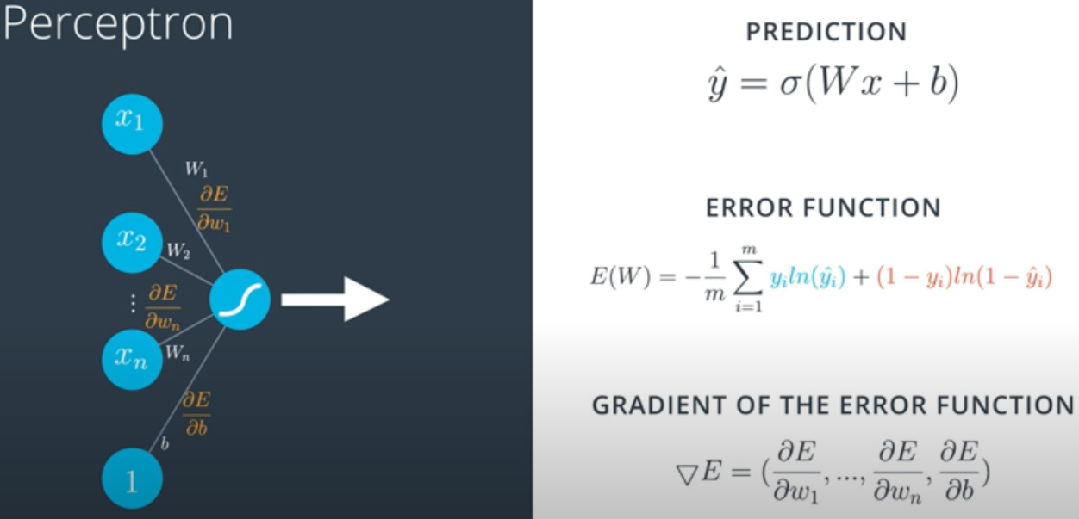

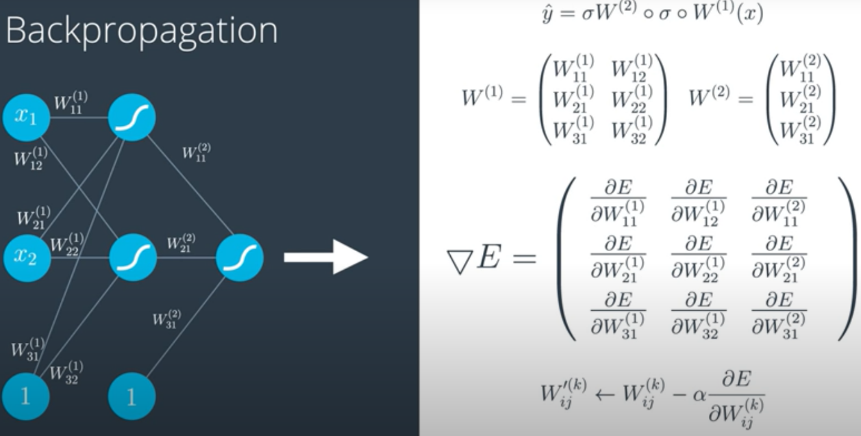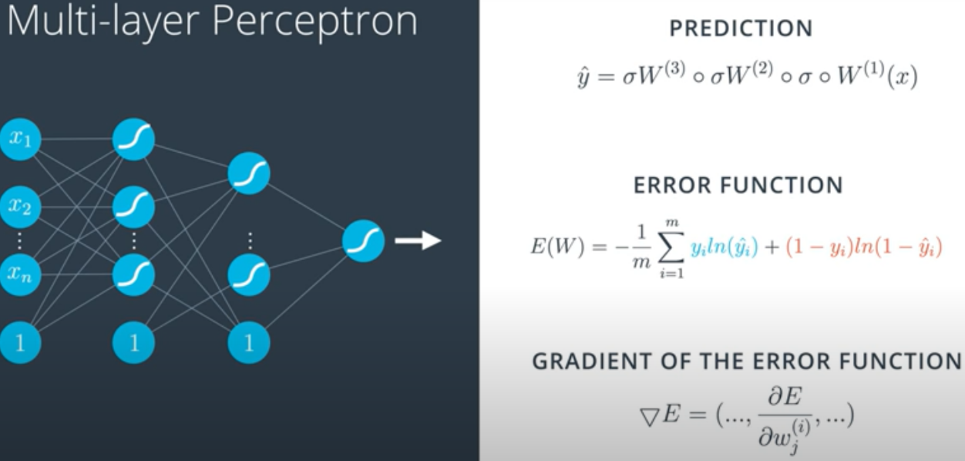

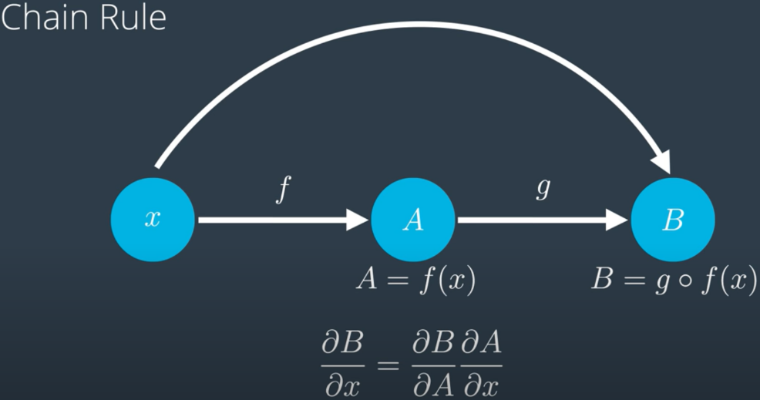**Chain rule**

* Feedforwarding is composing bunch of functions
* Backpropagation is decomposing (i.e. computing partial derivatives) of output w.r.t. input

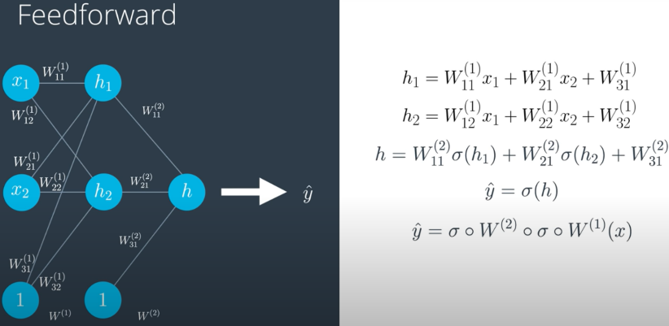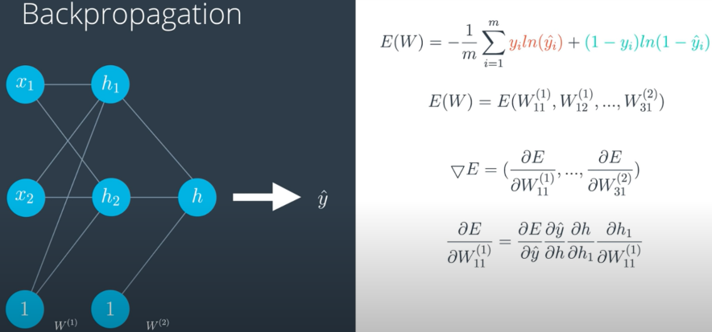**Training NN with Backpropagation**

**Since we know,**

$$\frac{∂E}{∂\hat{y}} = y - \hat{y}$$

**And we can calculate remaining by simple decomposition,**

$$\frac{∂\hat{y}}{∂h} = σ(h)*(1-σ(h))$$

$$\frac{∂h}{∂h_{1}} =\frac{∂(W_{11}^{(2)}σ(h1) + W_{21}^{(2)}σ(h2) + W_{31}^{(2)}σ(h3))}{∂h_{1}} = W_{11}^{(2)} * σ(h)*(1-σ(h))$$

$$\frac{∂h_{1}}{∂W_{11}^{(1)}} =\frac{∂(W_{11}^{(1)}x_{1} + W_{21}^{(1)}x_{2}+ W_{31}^{(1)}x_{3})}{∂h_{1}} = x_{1}$$

**Thus resulting:**

$$\frac{∂E}{∂W_{11}^{(1)}} = \frac{∂E}{∂\hat{y}} * \frac{∂\hat{y}}{∂h} * \frac{∂h}{∂h_{1}}*\frac{∂h_{1}}{∂W_{11}^{(1)}} = (y - \hat{y})*σ(h)*(1-σ(h))*W_{11}^{(2)} * σ(h)*(1-σ(h))*x_{1}$$

**Generalizing,**

$$\frac{∂E}{∂W_{ij}^{(i)}} = \frac{∂E}{∂\hat{y}} * \frac{∂\hat{y}}{∂h} * \frac{∂h}{∂h_{i}}*\frac{∂h_{i}}{∂W_{ij}^{(i)}} = (y - \hat{y})*σ(h)*(1-σ(h))* [ W_{ij}^{(i)} * σ(h)*(1-σ(h)) ] *x_{j}$$

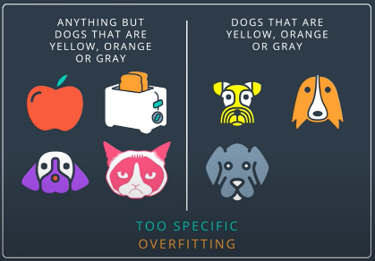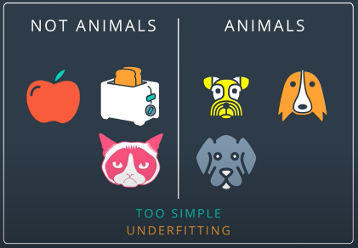**Model optimization**

* Go for simpler model
* Underfitting (Error due to bias): Too simple model (Try killing dragon with flycatcher)
* Overfitting (Error due to variance): Too complex model (Try killing fly with missile)

Not Studying and failing : Underfit model

Studying and Passing : Good model

Memorizing book and failing : Overfit model

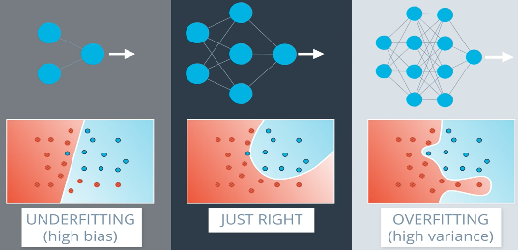

**FINDING GOOD MODEL IS ALWAYS IMPOSSIBLE**

When perfect sized pant is not found, we choose a slightly larger size and use a proper belt

Similarly; **We choose a slightly complicated model and apply techniques to avoid overfitting**

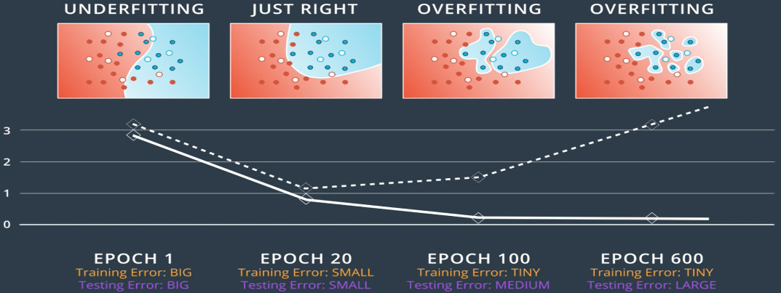

**Early stopping**

* **Training error** is always decreasing
* **Testing error**  is decreasing till sweet point, and then starts increasing as overfitting starts
* 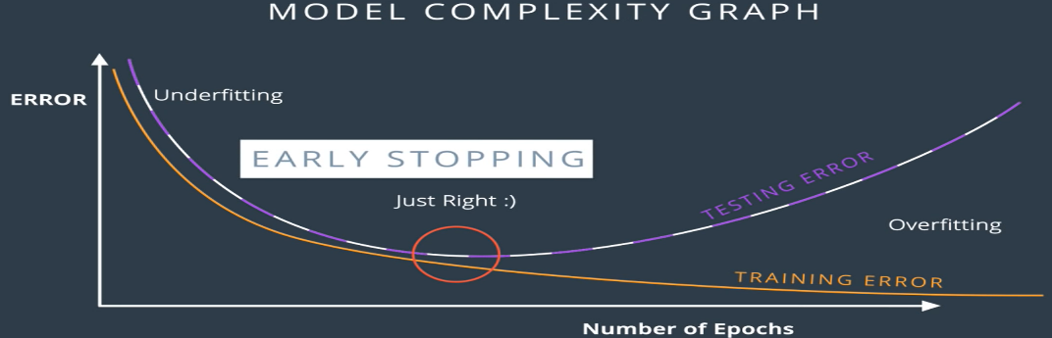**Hence, it is common practice to train till Sweet point**

**Regularization**

* **Though 2nd solution seems better classifier, it is hard limiting most of derivatives near 0**
* **Large coefficients lead to overfitting**

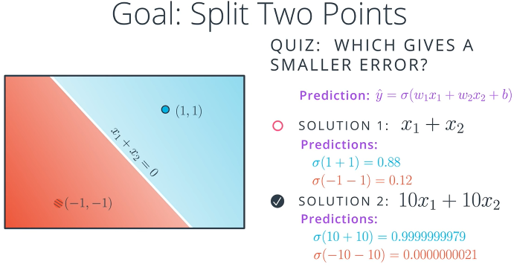

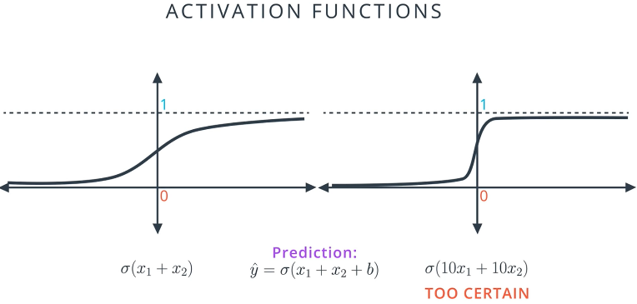

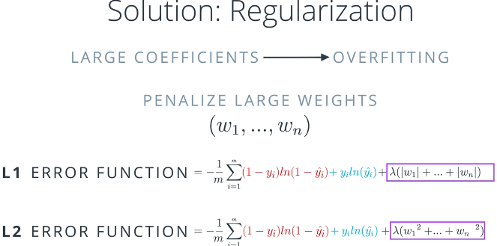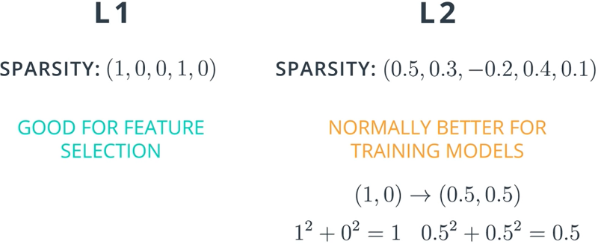

**Dropout**

* 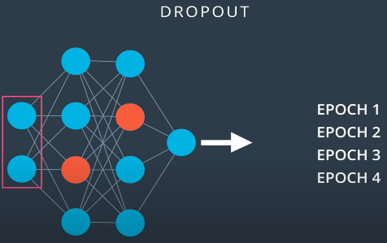When an arm develops due to continuous workout by single hand, we try to use alternate arms to develop both arms equally.



* **Similarly, neurons in e ach layers are randomly dropped during training to avoid influence of large weights on certain branches**

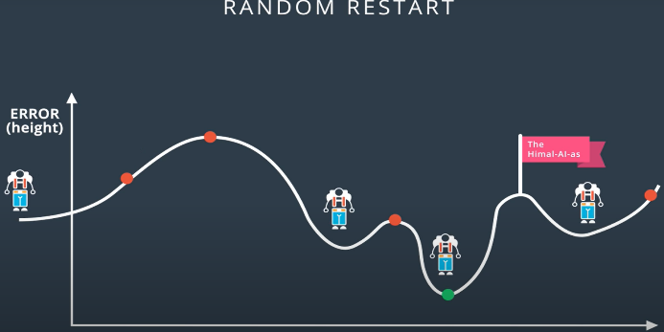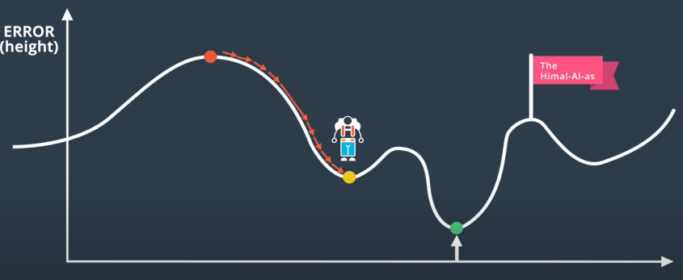**Problem: local minima Solution : random restart**

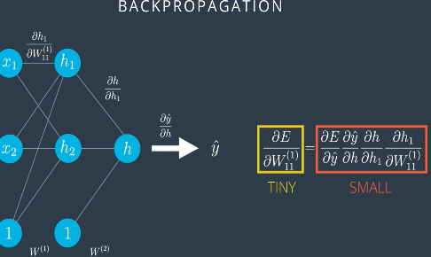**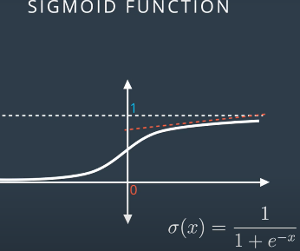Problem : Vanishing gradient Solutions : change activation**

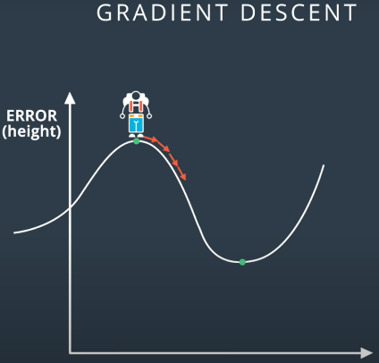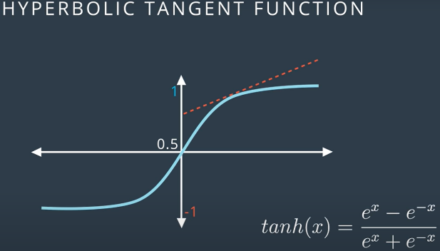

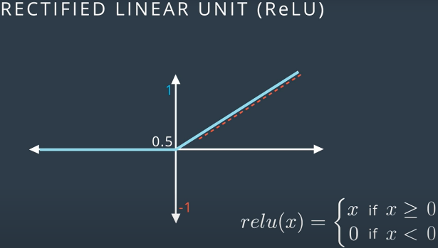**Sigmoid offers small derivative offered in flat area; which leads to further small gradients in back** **propagation**

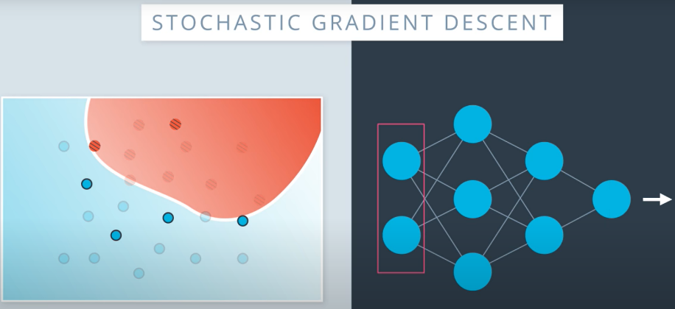**Batch/ stochastic gradient descend**

* Training on whole data in each epoch make NN large and sluggish.
* Rather, data is devided into euqal sized batches and small NN is trained on each batch during an epoch
* Hence, boundary is iteratively changed to optimal solution

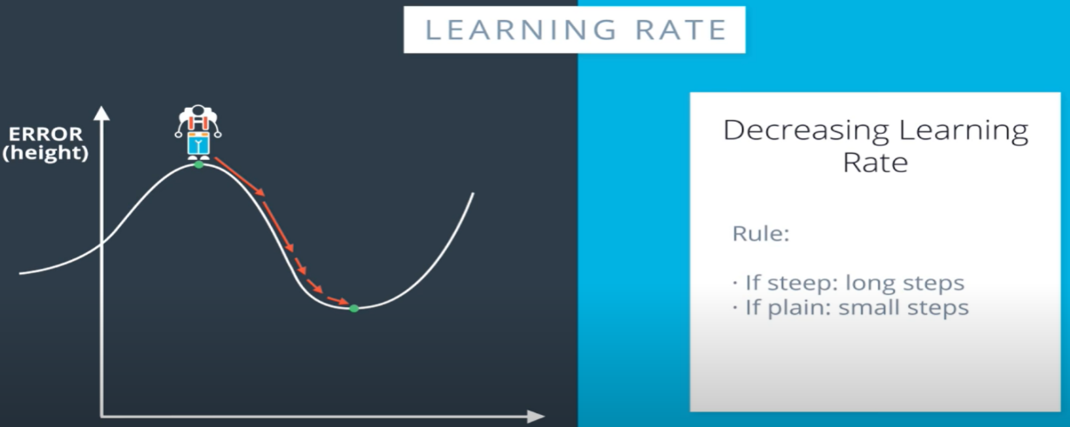

**Learning rate**

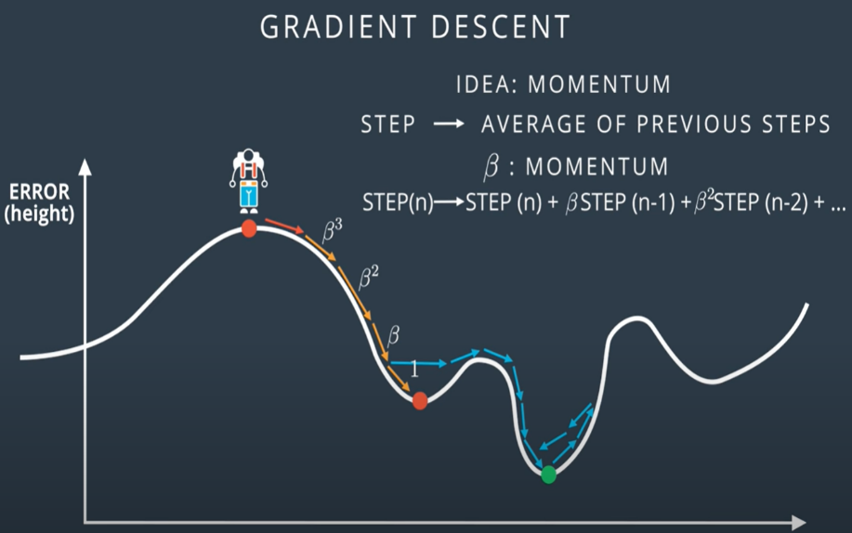

**Momentum : get over local minima hump**

* $β is constant between 0 →1$; hence it is more influenced by immidiate gradients, yet preserves memory of earlier gradients
* Once at global minima, it attempts to get over; but fails since both walls are steep enough